**Recent Advances in Augmented Reality**

Contents

Enabling Technologies 2

Head-Worn Displays (HWD) 2

Projection Displays 2

Interfaces and Visualization 3

User Interface and Interaction 3

Calibration and Auto-calibration 3

Augmented Reality Trends 3

AR in Mobile Devices 4

AR in NFTs 4

Developing and Designing for AR 4

Platforms 4

Common Augmented Reality Use Cases 5

Training and Education 5

Entertainment 5

Gaming 5

Advantages of Augmented Reality 5

E-Commerce 6

Healthcare 6

Conclusion 7

References 7

**Figure 1** 2

**Figure 2** 3

**Figure 3** 3

**Figure 4** 4

**Figure 5** 4

**Figure 6** 4

**Figure 7** 5

**Figure 8** 5

**Figure 9** 6

**Figure 10** 6

**Figure 11** 6

**Recent Advances in Augmented Reality**

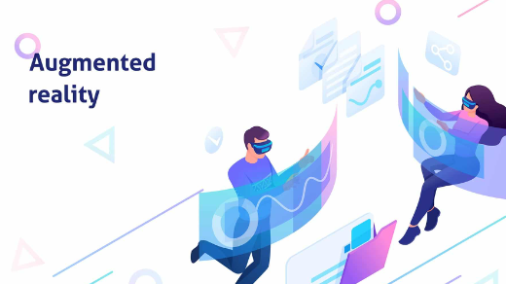What is augmented reality? An AR system supplements the real world with virtual (computer-generated) objects that appear to coexist in the same space as the real world. While many researchers broaden the definition of AR beyond this vision, we define an AR system to have the following properties:

**Figure 1**

■ combines real and virtual objects in a real environment;

■ runs interactively, and in real time; and

■ registers (aligns) real and virtual objects with each other

# Enabling Technologies

One category for new developments is enabling technologies. Enabling technologies are advances in the basic technologies needed to build compelling AR environments. Examples of these technologies include displays, tracking, registration, and calibration.

## Head-Worn Displays (HWD)

**Figure 2**

Users mount this type of display on their heads, providing imagery in front of their eyes. Two types of HWDs exist: optical see through and video see-through. The latter uses video capture from head-worn video cameras as a background for the AR overlay. Ideally, head-worn AR displays would be no larger than a pair of sunglasses. Several companies are developing displays that embed display optics within conventional eyeglasses. Micro Optical produced a family of eyeglass displays in which two right-angle prisms are embedded in a regular prescription eyeglass lens and reflect the image of a small color display, mounted facing forward on an eyeglass temple piece.

## Projection Displays

In this approach, the desired virtual information is projected directly on the physical objects to be augmented. In the simplest case, the intention is for the augmentations to be coplanar with the surface onto which they project and to project them from a single room-mounted projector, with no need for special eyewear. Generalizing on the concept of a multiwalled Cave automatic virtual environment (CAVE), Raskar and colleagues8 show how multiple overlapping projectors can cover large irregular surfaces using an automated calibration procedure that takes into account surface geometry and image overlap.

# Interfaces and Visualization

In the last five years, a growing number of researchers have considered how users will interact with AR applications and how to effectively present information on AR displays.

## User Interface and Interaction

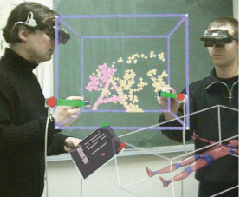Until recently, most AR prototypes concentrated on displaying information that was registered with the world and didn’t significantly concern themselves with how potential users would interact with these systems. Prototypes that supported interaction often based their interfaces on desktop metaphors (for example, they presented on-screen menus or required users to type on keyboards) or adapted designs from virtual environments research (such as using gesture recognition or tracking 6D pointers). In certain applications, such techniques are appropriate. In the RV-Border Guards game,45 for example, users combat virtual monsters by using gestures to control their weapons and shields. ARs are now used in phone cameras and now augmented reality is coming to common people in recent days.

**Figure 3**

## Calibration and Auto-calibration

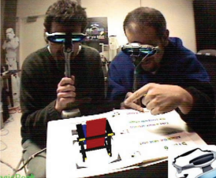AR systems generally require extensive calibration to produce accurate registration. Measurements may include camera parameters, field of view, sensor offsets, object locations, distortions, and so forth. The AR community uses well-established basic principles of camera calibration and developed many manual AR calibration techniques. One way to avoid a calibration step is to develop calibration-free renderers. For some applications, virtual augmentations should be indistinguishable from real objects. While high-quality renderings and compositions aren’t currently feasible in real time, researchers are studying the problem of photorealistic rendering in AR and of removing real objects from the environment.

**Figure 4**

# Augmented Reality Trends

Today in various different areas of our lives, we owe a lot to augmented reality (AR).

Considered one of the brightest technology building blocks of the future, AR has great potential as it can be evaluated in different ways in many different fields and gained greater momentum than expected as the social distancing rules that came with the pandemic.

## AR in Mobile Devices

AR features with high accessibility are frequently encountered in mobile applications. For example, Snapchat and Instagram provide AR and 3D filters that allow their users to entertain themselves and enjoy gamified interactions. Entertainment accessible to all helps AR to keep its cool side and attract the attention of all age groups.

**Figure 5**

## AR in NFTs

Today, most of the games that offer their own in-game economy with blockchain are on the way to offering AR and VR experiences by preparing themselves for the Metaverse.

**Figure 6**

While increasing the use cases of augmented reality via new digital ownership rights, AR NFTs offer a wider range of possibilities and utility to users. We're sure you remember Pokemon Go. Although it is not connected with NFTs, it quickly became popular around the world as a good example of a game with location-based AR.

Now, AR NFTs that are attached to physical objects, location-based AR NFTs, and AR NFTs in gaming are all on the horizon for the gaming industry.

# Developing and Designing for AR

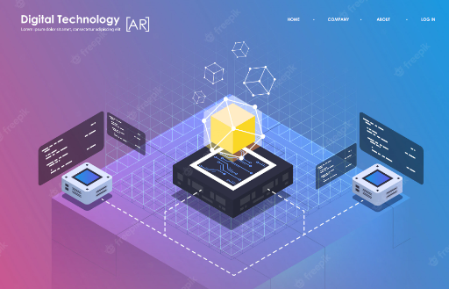AR development platforms are platforms on which you can develop or code AR apps. **Examples** include ZapWorks, ARToolKit, MAXST for Windows AR and smartphone AR, DAQRI, SmartReality, ARCore by Google, Windows’ Mixed Reality AR platform, Vuforia, and ARKit by Apple. Some allow the development of apps for mobile, others for P.C., and on different operating systems.

AR development platforms allow developers to give apps different features such as support for other platforms such as Unity, 3D tracking, text recognition, creation of 3D maps, cloud storage, support for single and 3D cameras, support for smart glasses.

## Platforms

Different platforms allow the development of marker-based and/or location-based apps. Features to consider when selecting a platform include cost, platform support, image recognition support, 3D recognition, and tracking is a most important feature, support for third-party platforms such as Unity from where users can import and export AR projects and integrate with other platforms, cloud or local storage support, GPS support, SLAM support, etc. The AR apps developed with these platforms support a myriad of features and capabilities. They may allow content to be viewed with one or a range of AR glasses that have pre-made AR objects, support for reflection mapping where objects have reflections, real-time image tracking, 2D and 3D recognition.

**Figure 7**

# Common Augmented Reality Use Cases

A lot more than helping people track down pocket monsters. In fact, in 2020, nearly every industry has found ways to apply AR technology to improve processes and outcomes.

## Training and Education

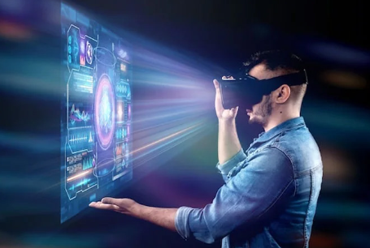Dynamic, AR-based instructions let people [perform new tasks more easily and quickly](https://trainingindustry.com/articles/learning-technologies/augmented-reality-the-future-of-job-training/) than traditional training methods (like instruction manuals). As wearable devices like AR-powered smart glasses, AR contacts and AR headsets become more widely available, the potential for training via augmented reality will be tremendous.

## Entertainment

AR has been enhancing entertainment for years. In 2012, a hologram of [Tupac Shakur appeared onstage with Snoop Dogg](https://theundefeated.com/features/the-strange-legacy-of-tupacs-hologram-after-coachella/) at Coachella. This year, a fully CGI avatar who happens to be an Instagram influencer was [signed by talent agency CAA](https://variety.com/2020/digital/news/miquela-virtual-influencer-signs-caa-1234599368/). And to adapt to the realities of the COVID-19 pandemic, the band Real Estate offered a “[Quarantour](https://realestatequarantour.com/)”, meaning an AR-powered tour to replace the live shows it had to cancel because of worldwide quarantines.

**Figure 8**

## Gaming

Today, [dozens of other games](https://thinkmobiles.com/blog/best-augmented-reality-games/) incorporate AR elements. The popularity of AR games is no surprise, as gaming was one of the most obvious early applications that many people saw for AR and VR capabilities. Today, most of these augmented reality experiences are made possible by smartphones. However, the development of more advanced AR devices (like Apple’s AR glasses or Microsoft's Hololens) could open the door to even more applications in gaming industry.

# Advantages of Augmented Reality

**Figure 9**

AR technology has revolutionized the whole world.There are limitless advantages of augmented reality in every industry.

## E-Commerce

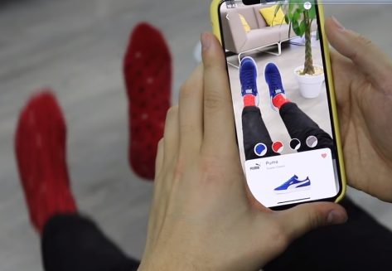AR can help your [e-commerce business thrive](https://www.banuba.com/whitepaper/facear-retail?hsLang=en). The proven benefits of augmented reality for e-commerce include:

**Figure 10**

>increase user engagement by [70%](https://aws.amazon.com/blogs/apn/audis-3d-online-car-configurator-uses-zerolight-to-deliver-a-fully-interactive-3d-experience/)

>boost conversions by almost [50%](https://venturebeat.com/2018/10/09/why-3d-technology-is-a-must-have-for-ecommerce/)

>reduce returns by 40%.

The core AR-powered solutions that revolutionize are [virtual try-on](https://www.banuba.com/blog/how-to-develop-a-virtual-makeup-try-on-app), placement preview, engaging user manuals, gamification, and [face filters](https://www.banuba.com/blog/ar-face-filters-20-ideas-for-developing-the-best-face-tracking-app).

[Virtual try-on solutions](https://www.banuba.com/blog/how-to-develop-a-virtual-makeup-try-on-app) help customers try products before they buy it.

For example, Wanna Kicks app by Wannaby. It enables users to try on their favorite and desired sneakers at home. No offline shopping, in-store experience, and wasted time.

Customers just need to download the app, find the desired shoe model, hold their feet on camera, and try sneakers in real-time. Once users are all set, they can digitally customize the chosen pair and proceed to the checkout procedure.

## Healthcare

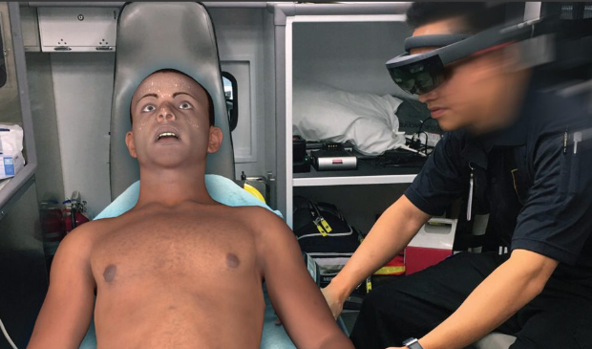Augmented reality revolutionizes the healthcare industry. AR-powered technologies improve the way companies train professionals, treat patients, and perform on the market.

**Figure 11**

First, augmented reality simulators help companies train their pre-hospital professionals.For example, PerSim.

It’s a realistic AR-based simulator program that allows EMTs, paramedics, and others to deal with real-life causes virtually. From trauma-related injuries to mass casualty events, professionals use the strengths of AR to learn, train and grow.Second, AR-powered applications help visualize and process patient information in a digital and visually-appealing way. It reduces human factor risks while delivering symptoms and medical diagnosis, and simplifies the way professionals share data.What’s more, augmented reality applications mean patients no longer need to struggle with failed procedures that may cause difficulties.

For instance, IV (intravenous injection).Nurses can now use AccuVein. It’s an AR-powered app that reduces potential human errors and failures to find and inject patients’ veins error-free. The solution scans a patient’s skin and accurately visualizes veins to conduct an injection.

# Conclusion

From different ways of researching and analysing, most of the data and information convince that AR technology is applicable not only on architecture industry, but also sectors that relating to architecture and design such as construction and visualisation. With AR being rather new and innovative in every aspect, I have done a general research on AR technology. This has allowed me to collect more information about AR before I focusing down my aims and objectives. Simultaneously, these researches also help supporting my studio projects as I get to know what can AR achieve in every aspects.

It has already prove that Augmented Reality could enhance the way we design for people. It has proven that with the characteristic of AR, people could comprehend and appreciate design more thoroughly. Indeed with all the supporting resources and analysis, I have to state that AR can change the dynamic of design by  making the process more transparent and comprehensive between designer and the community involved.

# References

|  |  |
| --- | --- |
| [1] | R. A. Yohan Baillot, R. B. S. F. S. F. and B. M. , "Recent Advances in," p. 47, 1997. |
| [2] | "ArtLabs," [Online]. Available: https://artlabs.ai/blog/top-augmented-reality-trends. |
| [3] | "Software Testing Help," [Online]. Available: https://www.softwaretestinghelp.com/what-is-augmented-reality/#Developing_And_Designing_For_AR. |
| [4] | "three kit," [Online]. Available: https://www.threekit.com/blog/what-is-augmented-reality. |
| [5] | "Keanhwa," [Online]. Available: https://keanhwa.wixsite.com/augmentedreality/conclusion. |
| [6] | D. Torkut, "banuba," 12 May 2022. [Online]. Available: https://www.banuba.com/blog/benefits-of-augmented-reality#:~:text=The%20advantages%20of%20augmented%20reality,stand%20out%20from%20the%20market.. |